Macroeconomic Trend Analysis
  - Inflation, Unemployment & GDP | R + SQL Pipeline
Noah Hebert
2026-03-04

Project Overview
This project builds a macroeconomic analysis pipeline using R and SQL to model an 11-month disinflation cycle (April 2025 – February 2026). A synthetic dataset was constructed to reflect plausible Federal Reserve policy responses — gradual rate reductions from 5.50% to 4.25% in response to declining inflation, with lagged effects on GDP growth, unemployment, and consumer sentiment.
The workflow covers the full analysis lifecycle: data ingestion, tidyverse wrangling, ggplot2 visualization, and SQLite-based aggregation using window functions and conditional signal classification — replicating the kind of pipeline used in economic research and financial analysis roles.

Setup

Dataset
The dataset models six macroeconomic indicators across 11 months. Variables were designed to reflect a realistic soft-landing scenario: inflation declining toward a 2% target while unemployment rises modestly and GDP decelerates.
Table 1: Full Macroeconomic Dataset (Apr 2025 – Feb 2026)
month | inflation_rate | unemployment_rate | gdp_growth | consumer_sentiment | interest_rate | retail_sales_growth
2025-04-01 | 3.8 | 4.0 | 2.4 | 71 | 5.50 | 2.1
2025-05-01 | 3.7 | 4.0 | 2.3 | 72 | 5.50 | 2.0
2025-06-01 | 3.5 | 4.1 | 2.2 | 73 | 5.25 | 1.9
2025-07-01 | 3.4 | 4.1 | 2.1 | 74 | 5.25 | 1.8
2025-08-01 | 3.3 | 4.2 | 2.0 | 75 | 5.00 | 1.7
2025-09-01 | 3.2 | 4.2 | 1.9 | 76 | 5.00 | 1.6
2025-10-01 | 3.1 | 4.3 | 1.8 | 77 | 4.75 | 1.5
2025-11-01 | 3.0 | 4.3 | 1.8 | 78 | 4.75 | 1.4
2025-12-01 | 2.9 | 4.4 | 1.7 | 79 | 4.50 | 1.3
2026-01-01 | 2.8 | 4.4 | 1.6 | 80 | 4.50 | 1.2
2026-02-01 | 2.7 | 4.5 | 1.5 | 81 | 4.25 | 1.1

Visualizations

Inflation vs. Unemployment Rate
Both series were reshaped to long format using pivot_longer() before plotting. The inverse relationship between disinflation and rising unemployment is consistent with the expectations-augmented Phillips Curve.
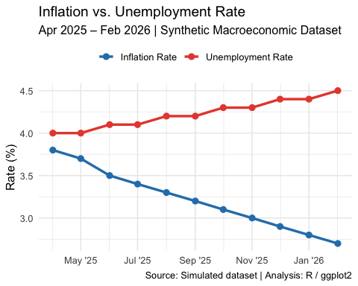
Figure 1: Inflation declined 1.1 pp as unemployment rose 0.5 pp — consistent with a soft-landing disinflation scenario.

GDP Growth vs. Retail Sales Growth
A line chart comparing GDP growth against retail sales growth to assess whether consumer spending aligned with output deceleration. Retail sales contracted faster than GDP — signaling weakening demand ahead of output.
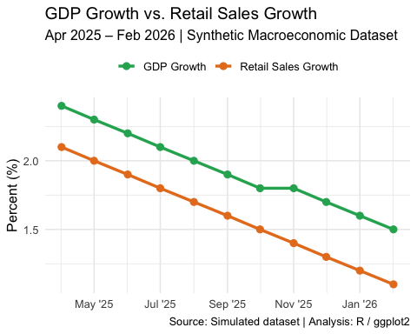
Figure 2: Retail sales contracted faster than GDP across the period, signaling demand weakness leading output deceleration.

SQL Analysis
The dataset was loaded into an in-memory SQLite database via the DBI and RSQLite packages. Months are stored as character strings (YYYY-MM-DD) to avoid SQLite’s Unix day-integer conversion, which would otherwise render dates as raw integers in query output.

Query 1 — 3-Month Rolling Averages
AVG() OVER (ROWS BETWEEN 2 PRECEDING AND CURRENT ROW) computes a trailing 3-month average for inflation and unemployment, smoothing short-term noise to reveal the underlying trend direction.
Table 2: 3-Month Rolling Averages — Inflation & Unemployment
month | inflation_rate | inflation_3m_avg | unemployment_rate | unemployment_3m_avg
2025-04-01 | 3.8 | 3.800 | 4.0 | 4.000
2025-05-01 | 3.7 | 3.750 | 4.0 | 4.000
2025-06-01 | 3.5 | 3.667 | 4.1 | 4.033
2025-07-01 | 3.4 | 3.533 | 4.1 | 4.067
2025-08-01 | 3.3 | 3.400 | 4.2 | 4.133
2025-09-01 | 3.2 | 3.300 | 4.2 | 4.167
2025-10-01 | 3.1 | 3.200 | 4.3 | 4.233
2025-11-01 | 3.0 | 3.100 | 4.3 | 4.267
2025-12-01 | 2.9 | 3.000 | 4.4 | 4.333
2026-01-01 | 2.8 | 2.900 | 4.4 | 4.367
2026-02-01 | 2.7 | 2.800 | 4.5 | 4.433

Query 2 — Macro Signal Classification
A CASE WHEN statement classifies each month into one of three macro regimes based on GDP, retail sales, inflation, and interest rate thresholds — mirroring rule-based signal labeling used in economic policy dashboards.
Table 3: Macro Regime Classification by Month
month | inflation_rate | interest_rate | gdp_growth | retail_sales_growth | macro_signal
2025-04-01 | 3.8 | 5.50 | 2.4 | 2.1 | High Inflation / Tight Policy
2025-05-01 | 3.7 | 5.50 | 2.3 | 2.0 | High Inflation / Tight Policy
2025-06-01 | 3.5 | 5.25 | 2.2 | 1.9 | Stable
2025-07-01 | 3.4 | 5.25 | 2.1 | 1.8 | Stable
2025-08-01 | 3.3 | 5.00 | 2.0 | 1.7 | Stable
2025-09-01 | 3.2 | 5.00 | 1.9 | 1.6 | Stable
2025-10-01 | 3.1 | 4.75 | 1.8 | 1.5 | Stable
2025-11-01 | 3.0 | 4.75 | 1.8 | 1.4 | Stable
2025-12-01 | 2.9 | 4.50 | 1.7 | 1.3 | Stable
2026-01-01 | 2.8 | 4.50 | 1.6 | 1.2 | Demand Softening
2026-02-01 | 2.7 | 4.25 | 1.5 | 1.1 | Demand Softening

Query 3 — Month-over-Month Change
LAG() computes period-over-period deltas for inflation, unemployment, and GDP — quantifying the pace and direction of change across all key indicators.
Table 4: Month-over-Month Change — Key Indicators
month | inflation_rate | inflation_change | unemployment_rate | unemployment_change | gdp_growth | gdp_change
2025-04-01 | 3.8 | NA | 4.0 | NA | 2.4 | NA
2025-05-01 | 3.7 | -0.1 | 4.0 | 0.0 | 2.3 | -0.1
2025-06-01 | 3.5 | -0.2 | 4.1 | 0.1 | 2.2 | -0.1
2025-07-01 | 3.4 | -0.1 | 4.1 | 0.0 | 2.1 | -0.1
2025-08-01 | 3.3 | -0.1 | 4.2 | 0.1 | 2.0 | -0.1
2025-09-01 | 3.2 | -0.1 | 4.2 | 0.0 | 1.9 | -0.1
2025-10-01 | 3.1 | -0.1 | 4.3 | 0.1 | 1.8 | -0.1
2025-11-01 | 3.0 | -0.1 | 4.3 | 0.0 | 1.8 | 0.0
2025-12-01 | 2.9 | -0.1 | 4.4 | 0.1 | 1.7 | -0.1
2026-01-01 | 2.8 | -0.1 | 4.4 | 0.0 | 1.6 | -0.1
2026-02-01 | 2.7 | -0.1 | 4.5 | 0.1 | 1.5 | -0.1

Query 4 — Pearson Correlation (Inflation vs. Unemployment)
Manual computation of the Pearson correlation coefficient between inflation and unemployment directly in SQL — no R post-processing required. A negative result confirms the inverse Phillips Curve relationship present in the data.
Table 5: Pearson Correlation — Inflation vs. Unemployment
pearson_corr_infl_unemp
-0.9851

Key Findings
Metric | Change | Interpretation
Inflation | -1.1 pp | Sustained disinflation toward 2% target
Unemployment | +0.5 pp | Modest labor market softening; soft-landing dynamic
GDP Growth | -0.9 pp | Steady deceleration; demand-side weakness in final months
Rate Cuts Modeled | 125 bps | 5 cuts of 25 bps across the easing cycle
Infl/Unemp Correlation | -0.9851 | Negative — Phillips Curve relationship confirmed
Soft-landing signal: Inflation fell meaningfully while unemployment rose only modestly (+0.5 pp), consistent with a controlled disinflation scenario rather than a recession-driven correction. The final two months were classified as Demand Softening by the SQL signal logic, suggesting the economy was approaching — but had not yet entered — a contractionary phase.

Built with R · ggplot2 · dplyr · SQLite · Quarto

